To build a political and ethical knowledge on economic activities: PEKEA

The argument is based on the observation that past economic recipes mainly based on mainstream, are faulty for the following reason. Economists striving to elaborate a rigorous science, have separated themselves from other social sciences and have elaborated models ignoring social, political and ethical dimensions and the finality of economic activities. For this reason, criticism or incremental small changes are not sufficient; time has come to gather and elaborate the elements of a social science able to illuminate the paths towards a more humane future.

The general foundations are drawn from the observation of concrete economies. Since the industrial revolution, the driving forces of "national" or "local" economic activities have been both enterprises and public policies guided by long-term strategies and views. Economic activities have not been primarily driven by markets and their "laws". However, if markets cannot be entrusted to make strategic choices and to give a long term vision, they are necessary. They are able to indicate for ordinary goods, within the chosen framework, what is economically viable, and we reject the idea of a central authority acting as a substitute for markets.

These foundations are based on ethical choices. We refuse the notion that our communities (local, national or global) become "Ecocracies" dominated by one sole economic logic. Communities must be driven by a collective search for their common interest defined and stimulated by their ethical commitments. We think that it is first at the local level that a humane society can be built where economic and social choices proceed from democratic consultation and dialogue. As far as decentralised decisions about what and how to produce are concerned, the organisation of a town or village, of local territories reflect concerns for present and future collective well-being. This is why PEKEA is keen on the participation of local authorities to its reflections.

What to do ?

Everyone, not only decision makers, has to change his/her way of thinking and doing.
Everyone must contribute to the renewal of thought .

To launch a research programme for
the social sciences and the humanities

The efforts by heterodox economists must combined and transcended to elaborate upon a new paradigm. This lies in revisiting, both theoretically and practically, social demands and individual and collective behaviours, taking into consideration individual and societal values. It also lies in examining the participatory processes for defining a desirable future and collective choices.

Activities
To gather, expose and/or produce, provide or discuss, empirical studies, theoretical analyses and concrete experiments that can help design and build a new world more brotherly than the one evolving around us.

The international multidisciplinary scientific board ensures the relevance, quality and orientation of works that receive the PEKEA label without being "PEKEA positions". Responsibility for these works remains that of their authors. However official PEKEA positions may be endorsed by the General Assembly, after favourable advice and proposal from the scientific board. PEKEA can also co-organise projects with the agreement of the Executive Committee.

Work in progress
The idea of PEKEA had emerged in 2001, on the basis of a general argument to build a Political and Ethical Knowledge on Economic Activities. The conference of Santiago de Chile (2002) specifiedy fundamental principles as a framework to guide the research programme. The conference in Rennes (2003) began the construction of the four knowledge blocks starting with the societal value. Ethics of fraternity appeared as central. In Bangkok (2004) we explored what could be a feasible common future under the conditions of a demanding responsibility. Again in Rennes (2005) PEKEA discuss the primacy of Democray upon Economy before going to Africa (2006) in order to analyse the interactions between the individual and collective behaviours.

The four interrelated blocks of knowledge to be built address the following items :

1) Societal value
2) Democracy facing Ecocracy
3) Individual and collective behaviours
4) The feasible common future

PEKEA : an NGO and a Global Network
PEKEA "on line" : http://www.pekea.org

More than an NGO, PEKEA is an open network gathering academics from various disciplines and people committed in concrete actions sharing the same objective.
Its participants seek to contribute to, or simply support reflections on this objective. They are individual members of PEKEA, members of associations or local authorities partnered with PEKEA and sharing the same objective and the same argument.

Currently, thousands of people are directly connected to the Network around the NGO Pekea, and through partner associations and local authorities in about fifty countries around the world.

Meetings and discussions

The communications presented during the previous conferences are available on the website. Forums are organised. You may access additional texts as well.
Following our previous meetings, some workshops are still in operation and will give echoes of their work. "Local" groups exist in various places. Labelized contributions will be put on PEKEA’s website. More and more organisations are becoming PEKEA partners. More and more people are joining in. There will be an important participation based on PEKEA's philosophy by many of us to works and events organised in different places.

…………………………………………………………………………
Supporting form to fill in and tick □ both sides

Last Name: First Name:

P □ professional in human and social sciences *
E □ someone committed in concrete actions**
C □ concerned citizen

*Graduated in :
** My organization association/ My local authority is willing to become a PEKEA partner □
Address :

Tel : Fax:
e-mail:

The refused World

Poverty endures ; inequalities in living conditions increase ; unemployment is endemic, even in "rich" countries where crises have been recurrent for more than a century ; extremely harsh living conditions and even famine remain structural in spite of the remedies for "development" applied for more than fifty years in "poor" countries.
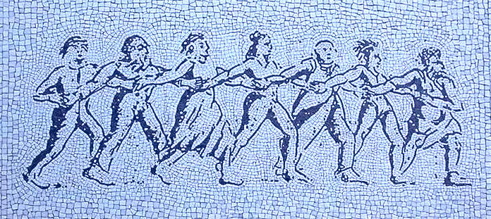
Economic growth has not reduced inequalities and has caused the progressive destruction of nature putting into jeopardy the survival of future generations. In spite of the existence of the UN, many decisive choices affecting the living conditions of the poorest have been made by the most powerful and the rich. The world is not democratically managed.

And yet, world capacities for agricultural and industrial production are sufficient to meet the basic needs of the planet's inhabitants. It could be possible through appropriate resource transfers and modified international trade rules for the world's population to satisfy their own basic needs. In each country and for the world as a whole, the problem is not so much one of production capacity, but rather of what and how to produce, how to distribute and exchange goods and resources, and what to consume. Leaving only to markets the task of answering these questions leads to a dead end, as markets have no ethics and ignore the political deliberations which are the only way to make satisfactory choices for societies.

…………………………………………………………………………

Supporting form to fill in both sides and to send to M.Humbert/ Pekea/ Faculté Sciences Economiques,
7 Place Hoche 35 065 Rennes cedex, France

I undersigned …………………………………

Agree with the contents and the objectives of the argument for PEKEA, I accept to be in the list of supporting people.
□ I join Pekea NGO and pay my membership fee *= C
by cheque □ herewith or through the website □ by Bank Card
Place:………………Date:…………………
Signature

* membership fee = C for M = Monthly average income
C=5 € for M<300 € // C=10 € for M<600 €
C=20 € for M<1200 € // C=50 € for M<3000 €
C=100 € for M>3000 € // C>1000 € = "donator"

_______________________________

another world is possible

___________________________________

the civil society is invited to devise an economy with a human face,
for a world
where we will live happy altogether.

PEKEA a global think tank network
With more than 700 researchers, and thousands of people involved in partner associations and local authorities

P E K E A
Political and Ethical Knowledge on Economic Activities

a political and ethical knowledge
on economic activities

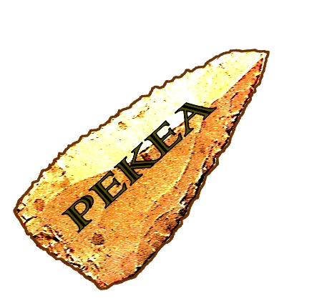

a Planet for
humanity and solidarity

http://www.pekea.org

